COS30031 Ben Holmes 103024841 Lab4 Report: 11/10/2024

## Question 1

1. It indicates the parameters of the array that is being created
2. Because we have “using namespace std;” at the top, it is good if using a small amount of libraries but can cause issues in larger programs.
3. Int indicates the type of the array, 3 indicates its size
4. It is an iterator of a1
5. V is an int
6. It means that it is a reference
7. My version does not allow [] either for the out of bounds. I assume that it does not work as at checks if there is suppose to be something there or not.

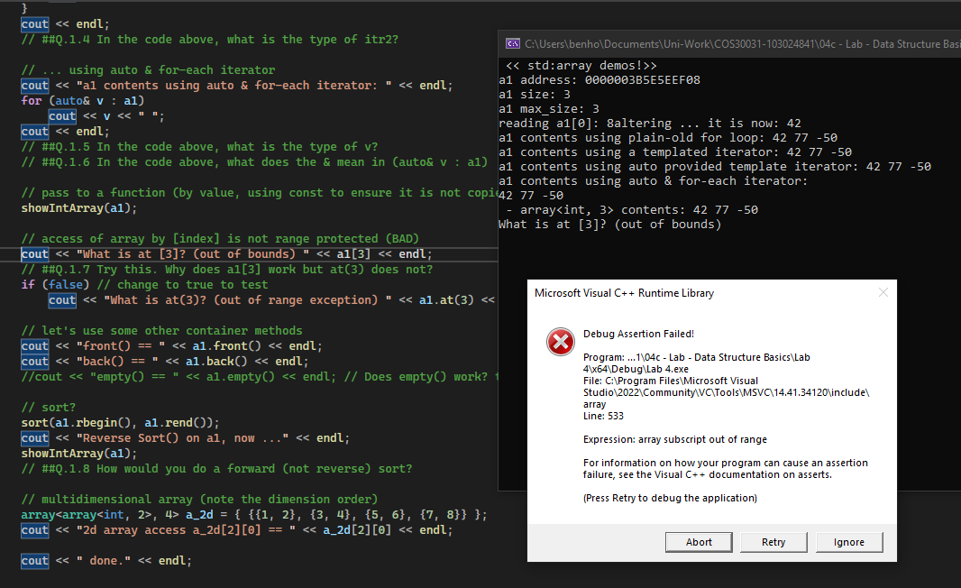

1. I would change the two iterators from reverse to forward (remove the r’s)

## Question 2

A4 becomes a copy of a1 with its type being array from auto

## Question 4

We use push and pop

## Question 5

As the only point of access is supposed to be the end/top of the stack there is no need for an at or []

## Question 6

A stack pop deletes the newest/last whereas queue pop deletes the oldest/first

## Question 7

No as list stores element internally in a doubly-linked list so you need to iterate through the entire list till you get to your value.

## Question 8

If you need to do insertions or erasures anywhere that isn’t the end, you will want to use list.

## Question 9

They were different.

## Question 10

ParticleClass(int x, int y)

## Question 11

Yes by the destructor being used after all 3 shows were done.

## Question 12

Yes it was deleted, I know this by adding a break point on the return 0; in main and there is no v2 stored.

## Question 13

It means to use the emplace_back function of vectore, which works differently to push_back.

## Question 14

Theoretically it would provide a very minor increase in speed, however the compiler either has to ignore it “because other code may legally cast it away” or it can figure out that the variable is constant anyway so doesn’t need the const in the C++ code. Const should still be used wherever necessary for ease of understanding and use, its just not useful for optimization.

<https://theartofmachinery.com/2019/08/12/c_const_isnt_for_performance.html>